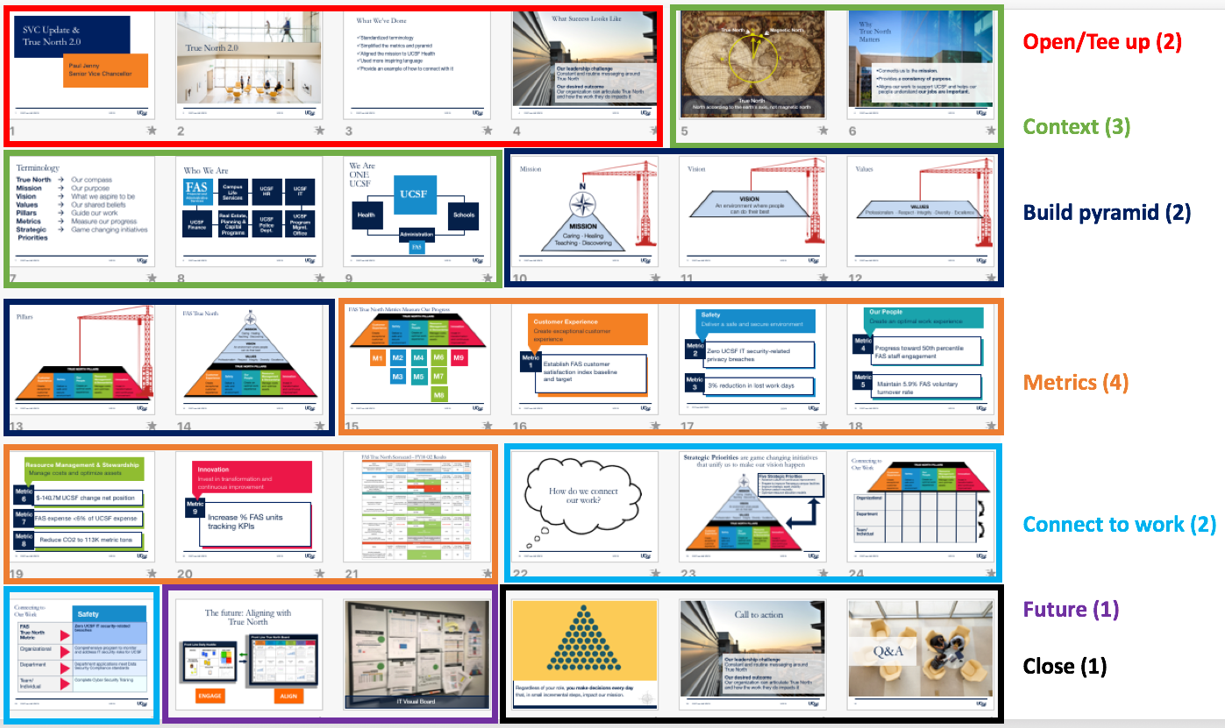

Section | True North Storyboard: Key messages
Open/  tee up  2 min | - Opening: Last year we were spending a lot of time talking about our 5 strategic priorities, but had not done enough to communicate our True North.  - We recognized that communicating True North was important because, when done right, it helps our people see that what they do matters to the UCSF mission.  - This is called alignment – helping our people connect and prioritize their work based on what moves us closer to our mission and vision.  - Why 2.O? Alignment happens in large part from two-way communications. We realized we were not consistently communicating or using the same language in talking about our True North.  - This was in part because we did not have clear definitions, too many words and metrics which made the task more difficult  - What we’ve done: We did some work to clarify and simplify the FAS True North (can refer to slide):  - reduced the words from 117 to 62 and we reduced the number of metrics from 17 to 9  - What success looks like: Our jobs as leaders is to connect local work to the bigger picture. True North is a tool to help. Success is an organization that feels inspired by our mission and purpose and knows how their work impacts it.
Context  3 min | - True North big picture: Let’s start with the biggest picture: What *is* True North?  - True North is our compass.  - Reference to nautical times and the early years of navigation.  - Why it matters: As a support organization, we do not produce the mission, we support the mission. As such, a having a True North is especially important for us to help our staff understand their role in contributing to the UCSF mission and feel inspired to come to work.  - Terminology: We want to build a shared understanding of the key terms and concepts related to True North; reference terminology.  - Who are we? We are the City Managers of UCSF.  - Together, we build, support and maintain the environment where every person at UCSF can do their best to accomplish our mission of Caring, Healing, Teaching & Discovering.  - We are one UCSF: FAS is a critical part of the UCSF eco system.
Build Pyramid  2 min | - Build the pyramid: I will now walk you through our revised True North:  - Mission is our purpose.  - We aligned our mission to that of UCSF Health with the understanding that we are all one UCSF with a mission of Caring, Healing, Teaching, Discovering.  This is what inspires us and why we are here.  - Vision is what we aspire to be.  - While we don’t teach, heal, provide direct care or make research discoveries, we build, support and maintain the environment that makes advancing health worldwide possible.  - If we can create the best environment, it creates an ecosystem where ALL staff can be their best.  - PRIDE Values capture how we conduct ourselves to create a collaborative culture: With Professionalism, Respect, Integrity, Diversity and Excellence.  - Pillars guide our work. Balanced areas of focus that serve as a guide for our work and bring our mission and vision to life. As a general rule of thumb, efforts to advance one pillar should not rob from another.  - Together, these components build the foundation of our True North.
Metrics  4 min | - Metrics measure our progress. Metrics & targets are part of the FAS True North and reflect how we will measure our progress in each pillar – are we taking steps in the right direction. Is what we are doing in one pillar taking away from another?  - Right now we have 9 metrics distributed among the five pillars, simplified from the original 17.  - Customer experience pillar Creating an exceptional customer experience helps create an environment where people can do their best.  - Metric 1: Establish FAS customer satisfaction index baseline and target.  To better measure this, we have just completed rolling out a new customer satisfaction survey.  - Surveys better reflect our customers’ experience in getting something done  - Provides more frequent feedback  - Safety pillar Deliver a safe and secure environment. Our safety pillar focuses on our role in supporting both employee safety and data security for all of UCSF.  - Metric 2: Zero UCSF IT security-related privacy breaches  - It is the law and critical to protect patient privacy and UCSF’s reputation. There can also be financial implications.  - Metric 3: 3% reduction in lost work days due to injury  - The goal is to reduce injuries, encourage safety practices and to demonstrate compliance by seeking work modifications so campus employees can return to work safely.  - People pillar This pillar focuses on the people within FAS.  - Engaged staff members are fully involved in and enthusiastic about their work. They act in ways that support their own success and further our mission.  - Two metrics for this pillar – one annual and one monthly  - Metric 4: Progress toward 50th percentile FAS employee engagement (annual)  - Metric 5: Maintain 5.9% FAS voluntary turnover rate (monthly)  - Resource Management & Stewardship pillar This pillar focuses on FAS’s role in proving leadership and expertise to manage and steward UCSF’s assets.  - Metrics track the financial wellbeing of UCSF, FAS’s growth relative to UCSF, and progress toward our carbon neutrality goal.  - Metric 6: $-140.7M UCSF consolidated change in net position  - Guided by comprehensive 10-year enterprise plan which serves as a strategic roadmap and helps drive optimal decision making. In some years, we have a negative net position, but through careful management, we guide the University toward long term financial sustainability.  - Metric 7: FAS expense <6% of UCSF expense  - Measures our growth of expenses relative to UCSF’s  - Metric 8: Carbon neutrality index (expressed in metric tons of CO2 emitted)  - UC Sustainable Practice Policy sets goal for us to achieve carbon neutrality by 2025  - Innovation pillar To create an environment where people can do their best, administration must invest in innovation and improvement.  - Represents the PDCA cycle which encourages us to go beyond taking of efforts to innovate and improve, but encourages us to embrace the PDCA (Plan-Do-Check-Adjust) cycle for so we can engage our staff to problems solve and improve as we go.  - Metric 9: Increase % FAS units* tracking KPIs (Key Performance Indicators)  * proxy for units = the 28 Direct reports of SVC (Paul’s direct reports)  - UCSF Health is using this same metric. Uses a survey that goes to 28 direct reports of SVC’s direct reports asking if they are using viability boards with KPIs and if they are regularly updating results  - Scorecard: We have collected 2 quarters of results for FY18 on our True North Scorecard. We are establishing a regular reporting and communication process to keep us all informed of our progress.
Connect to work  2 min | - Connect to work: Advancing our True North takes a combination of large cross-organization Strategic Priorities, as well as department and team level efforts.  - Strategic Priorities are game-changing initiatives that unify us to make our vision happen. Ideally, they impact multiple pillars.  - An example is our work to improve Parnassus. – The Strategic Priority here has a 12 month time frame narrowly focuses on improving measurement of deferred maintenance and taking on some more immediate beautification projects. However, this is the tip of the iceberg on our unifying FAS to showcase all the great work we are doing at Parnassus in the short, medium and longer term.  - Align down to individual level: Departments, teams and individuals look across all the pillars for ways to align their work  - Alignment happens through catch ball conversations between leaders and staff to connect, translate and filter their work to have a meaningful impact on the True North pillars and metrics  - An example of how different levels in FAS can align work to our TN metric of zero IT security related breaches (refer to slides)
Future  1min | - Future: Picture is of ADE (Active Daily Engagement) tools used by UCSF Health. As part of our Strategic Priority to Create a Culture of continuous improvement, we are beginning to adopt this Lean practice called Active Daily Engagement.  - ADE in FAS Some units are just now trying out Active Daily Engagement. Here is a Vis Board we saw in IT.  - Imagine a future where anyone in your organization can see this “dashboard” that engage them in problem solving that show how their work aligns with True North.
Close/  Call to action  1min | - Individual/decisions you make every day: Regardless of your role, you make decisions every day that, in small incremental steps, impact our mission.  - True North must become the backdrop that informs each of those decisions; each of those steps.  - Every one of us in this room has a call to action to talk about our True North, and help our people connect their work to impact it.  - Ultimately, we want all of our people to feel like what they do matters to the UCSF mission.  - Thank you for all of your hard work in supporting UCSF

